info@stanzafitness.com
stanzafitness.com

Training & Goal Assessment
Name:

1. Are there any particular exercises you really enjoy/would like to keep in your program?

2. Is there anything/body part/lift/mindset/habit etc you would specifically like to address during the next training block?

3. Are there any particular exercises you don’t enjoy/get on with that you’d not like in your program?

4. Physically, are there any areas that you particularly feel need improvement or you would like to work on?

5. Are there any other specific goals in regards to training or coaching that you wish to achieve?

6. Strength wise, are there any lifts you would like to particularly improve?

7. Do you have any injuries you’d like or need to address in your training program?

8. Does your current training plan/split work for your lifestyle? Or have any past training splits/programs worked for you? If so, why?

8. Do you feel that you’re adequately pushing yourself in your training sessions?

9. Are you finding your current program easy to adhere to? Or what do you find easy to adhere to?

10. Do you have any questions regarding training at the moment?
.

11. How many times are you/would you feasibly be able to train per week?

12. What are your overall goals for your next training program?

13. If you’ve followed previous programs, have they worked? If they haven’t, why not?

14. What benefits do you think you could get from having a program and a coach?

15. How long do your training sessions last? And does this match with how long you would like them to be?

16. Have you used any specific methods to track your training? E.g volume/intensity/load/rep schemes etc? If no, is there a reason for this?

Please email info@stanzafitness.com as soon as possible so we can address your goals as quickly as possible.

Regards,
Stanza Fitness Team

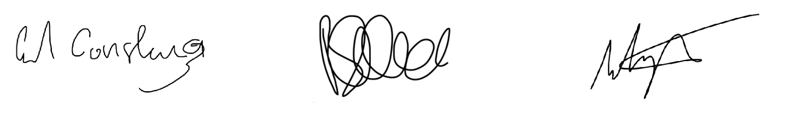

Stanza Fitness
7 Trim Street
Bath
BA1 1HB

